

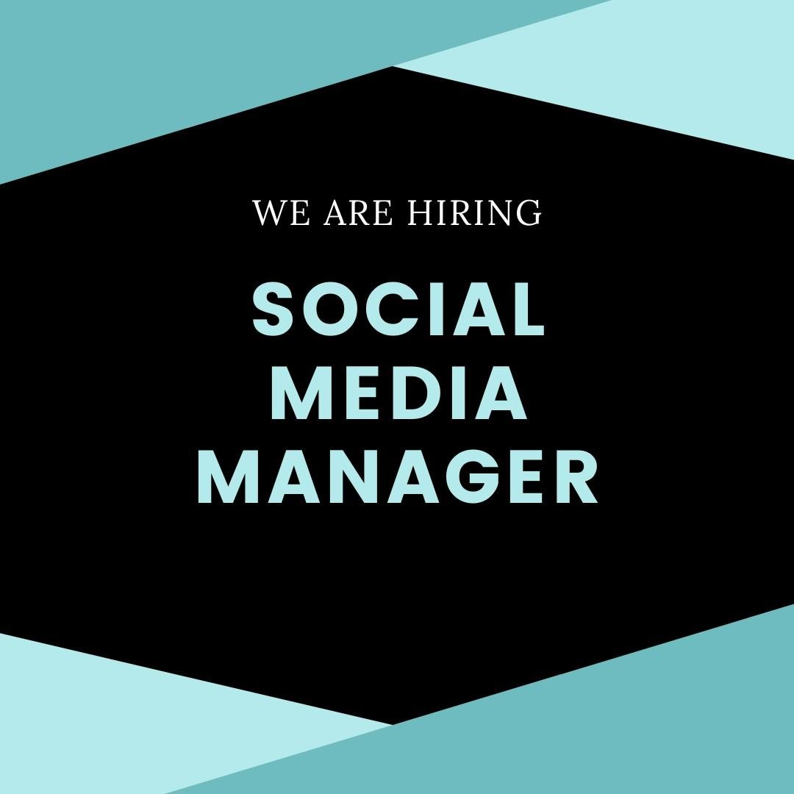

# Position: Multi-Platform Social Media Manager Location: Remote (Full-time or Part-time)

**Salary: Competitive, based on experience and passion About Us:**

At Travel + Leisure Co., we are a global leader in membership and leisure travel, offering an array of exceptional vacation experiences through our nearly 20 renowned travel brands. With a portfolio that includes Wyndham Destinations, Panorama, and Travel + Leisure Group, we are dedicated to providing unparalleled travel services and inspiration to millions of owners,

members, and subscribers around the world.

# Role Overview:

We are on the lookout for a dynamic and innovative Multi-Platform Social Media Manager to join our remote team. In this exciting role, you will drive our social media presence across various platforms, crafting and executing strategies that captivate and engage our audience. Your mission will be to elevate our brand’s voice, create compelling content, and leverage social media to inspire travel enthusiasts globally.

# Key Responsibilities:

* Develop and implement comprehensive social media marketing strategies across multiple platforms.
* Engage with followers and customers, responding to inquiries and fostering a vibrant online community.
* Design and execute content strategies that align with our brand's goals and resonate with our audience.
* Optimize social media profiles and campaigns to enhance performance and reach.
* Analyze social media metrics to track success and inform future strategies.
* Collaborate with our creative team to produce engaging content and innovative social media campaigns.

# Qualifications:

* Proven expertise in Social Media Marketing and Social Media Optimization (SMO).
* Exceptional communication and writing skills.
* Demonstrated experience in crafting effective content strategies.
* Track record of successfully growing and engaging social media audiences.
* Proficiency with social media analytics and management tools.
* Strong organizational and time-management abilities.
* Ability to thrive in a fast-paced, collaborative environment.
* Relevant degree in Marketing, Communications, or a related field.

# Why Join Us:

* Flexible remote work arrangement with options for full-time or part-time schedules.
* Competitive salary, with opportunities for negotiation based on your experience and enthusiasm.
* Generous benefits package, including holiday bonuses and more.

# Equal Opportunity Employment:

Travel + Leisure Co. is committed to creating an inclusive environment for all employees and applicants. We celebrate diversity and are dedicated to providing equal employment opportunities regardless of race, color, religion, age, sex, national origin, disability, genetic information, protected veteran status, sexual orientation, gender identity or expression, or any other characteristic protected by law.

If you are passionate about travel and social media, and excited to make an impact with a leading global brand, we invite you to apply and join us on this journey!